**DAILY ONLINE ACTIVITIES SUMMARY**

|  |  |  |  |  |  |  |  |  |
| --- | --- | --- | --- | --- | --- | --- | --- | --- |
| **Date:** | **21-05-2020** | | | | | **Name:** | **Pavana P** | |
| **Sem & Sec** | **6A** | | | | | **USN:** | **4AL17CS057** | |
| **Online Test Summary** | | | | | | | | |
| **Subject** | | **Operating System.** | | | | | | |
| **Max. Marks** | | **30** | | **Score** | | | **25** | |
| **Certification Course Summary** | | | | | | | | |
| **Course** | **INTRODUCTION TO INFORMATION SECURITY** | | | | | | | |
| **Certificate Provider** | | | Great learning  Academy | | **Duration** | | | 7hours |
| **Coding Challenges** | | | | | | | | |
| **Problem Statement:** 1.Getting a message printed through Applet.  2. Applet Demo  3.  Write C Program to create Singly Liked List with n elements and reverse the elements  4. Write a Java Program to Demonstrate a Basic Calculator using Applet  5.Write a C program to construct a singly linked list by removing duplicate elements in the sorted linked list  6. Write a java program to implement round robin scheduling algorithm.Calculate AVG WT AND TAT.  7.  write a simple applet java program to check whether the given number is armstrong number or not | | | | | | | | |
| **Status: Completed** | | | | | | | | |
| **Uploaded the report in Github** | | | | | **YES** | | | |
| **If yes Repository name** | | | | | **DAILY STATUS** | | | |
| **Uploaded the report in slack** | | | | | **YES** | | | |

**Online Test :**

Subject:-Operating System.

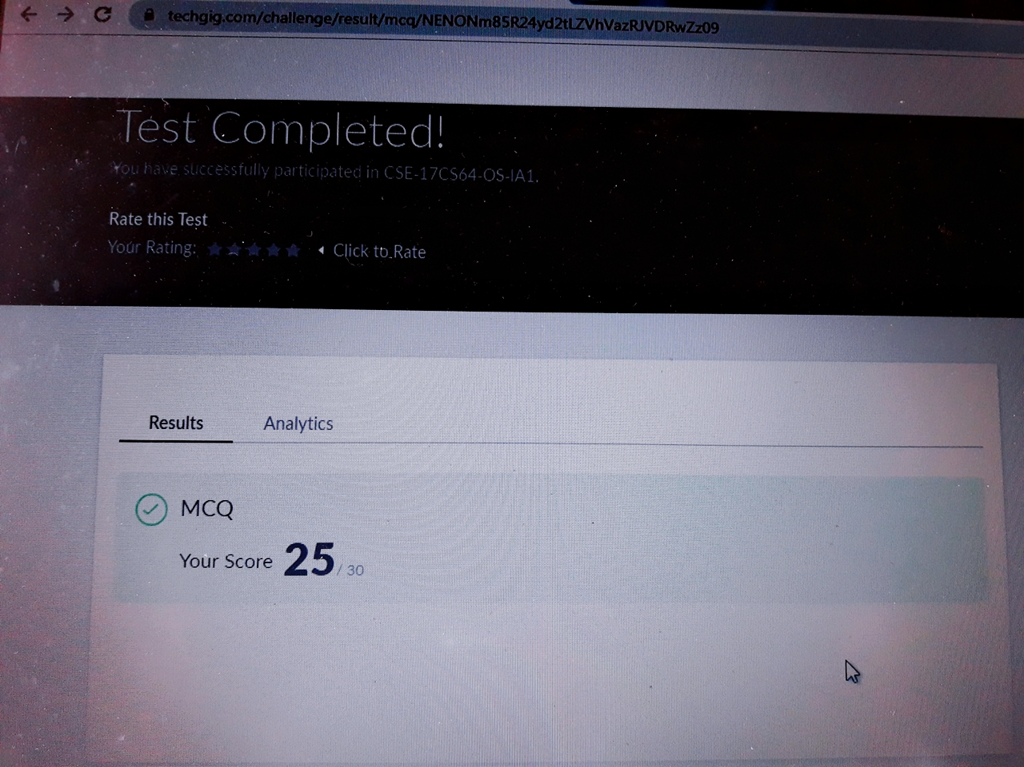

Certification Course Details:

**Introduction to Information Security:**

Today I have completed these topics:

1.Innovation in CyberSecurity

2.Its Applications and it’s Features.

3.Future of Cryptography.

4.Quantum Computing.

.

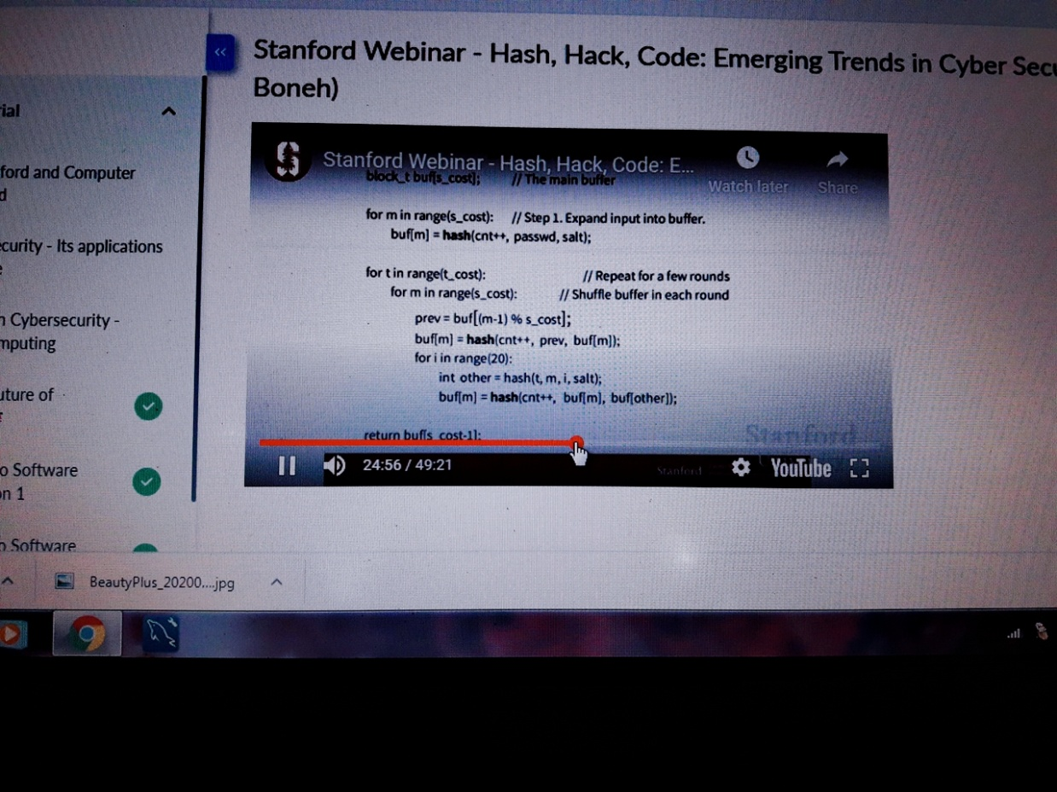

Coding Challenges Details:

**https://github.com/pavana-p-kulal/DAILY-STATUS/tree/master/21-5-20/Online%20Coding**